TITLE OF PAPER
[Title: uppercase, Times New Roman, font size 14, centered, single spacing paragraph]

(Tajuk Artikel dalam Bahasa Malaysia)
[Translation in Bahasa if paper in English and vice versa: Times New Roman, font size 12, centered, single spacing paragraph]

Author Name^{1*}, Author Name², Author Name³
[Use full name of all authors, Times New Roman, font size 10, superscript 1, 2, 3 etc. to indicate affiliation, centered, single spacing paragraph]

¹School of Chemical Science and Food Technology, Faculty of Science and Technology
²School of Applied Physics, Faculty of Science and Technology
Universiti Kebangsaan Malaysia, 43600 UKM Bangi, Selangor, Malaysia
[Indicate authors’ affiliation with superscript 1, 2, 3 etc. and start each address on new line, Times New Roman, font size 9, italic, centered, single spacing paragraph]

*Corresponding author: email address [Times New Roman, font size 9, italic]

Abstract
This template gives formatting guidelines for authors preparing papers for publication in the Malaysia Journal of Analytical Science. The authors must follow the instructions given in the document for the papers to be published. You can use this document as both an instruction set and as a template into which you can type your own text.

Keywords: [maximum 6, Times New Roman, font size 9 and text position left. Leave one blank line after abstract]

Abstrak
Template ini adalah format garis panduan bagi penulis yang menyediakan artikel atau makalah untuk disiarkan dalam Jurnal Malaysia Sains Analisis. Pengarang mesti ikut arahan yang diberikan dalam dokumen setiap artikel atau makalah yang akan disiarkan. Anda boleh menggunakan dokumen ini sebagai sampel set panduan penulisan dan sebagai templat ke dalam makalah anda dengan terma teks anda sendiri.

Kata kunci: [maksima 6, saiz huruf 9 and santak kiri. Selang satu baris selepas abstrak]

[Abstract words in English and Bahasa Malaysia. Use Times New Roman, 9 point font with text left and right justified and single spacing paragraph. Leave two blank lines before text of paper]

Introduction
[All first order headings use Times New Roman, font size 10, bold and centered]
This template gives formatting guidelines for authors preparing papers for publication in the Malaysia Journal of Analytical Science. The authors must follow the instructions given in the document for the papers to be published. You can use this document as both an instruction set and as a template into which you can type your own text.

[The text should be left and right justified, Times New Roman, font size 10, unindented and single spacing paragraph. Metric units should be used in their accepted abbreviated form. Chemical symbols should be specified and spelled out for the first time, thereafter the symbol used]

Materials and Methods
Study Area [Second order headings should be bold, 10 point font and unindented]
This template gives formatting guidelines for authors preparing papers for publication in the Malaysia Journal of Analytical Science. The authors must follow the instructions given in the document for the papers to be published. You can use this document as both an instruction set and as a template into which you can type your own text [1,2,3]. References must following numerical order.

Result and Discussion
This template gives formatting guidelines for authors preparing papers for publication in the Malaysia Journal of Analytical Science. The authors must follow the instructions given in the document for the papers to be published. You can use this document as both an instruction set and as a template into which you can type your own text.

Table 1. [Table text and caption should centered, Times New Roman, font size 10, included in body text]
 | Title 2 | Title 3 | Title 4 | Title 5 | Title 6
Text A
Text B
Text C

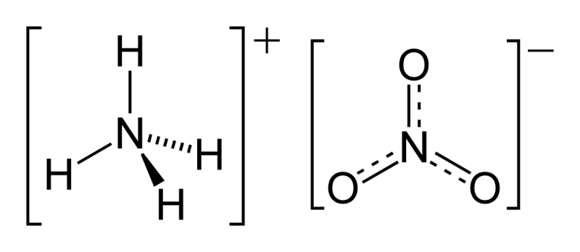
Figure 1. [illustration text and caption should centered, font size 10, included in body text]

Conclusion
This template gives formatting guidelines for authors preparing papers for publication in the Malaysia Journal of Analytical Science. The authors must follow the instructions given in the document for the papers to be published. You can use this document as both an instruction set and as a template into which you can type your own text.

Acknowledgement
This template gives formatting guidelines for authors preparing papers for publication in the Malaysia Journal of Analytical Science. The authors must follow the instructions given in the document for the papers to be published. You can use this document as both an instruction set and as a template into which you can type your own text.
[This should be included whenever appropriate as a separate section before Reference section, Times New Roman, font size 10]

References
[Listed in numerical order in the References, Times New Roman, font size 10, left and right justified and single spacing paragraph with format:
Journal – authors, years, title of paper. journal title, volume, issue number, and pages. (Use: APA format system)
- Hanif, M. F., Latif, M. T. and Othman, M. R. (2011). Atmospheric Surfactants around Lake Ecosystem of Tasik Kenyir, Terengganu. Malaysian Journal of Analytical Sciences, 15 (1): 1 – 7.
- Wahab, N. A. A., Darus, F. M., Isa, N., Sumari, S. M. and Hanafi, N. F. M. (2012). Heavy Metal Concentration of Settled Surface Dust in Residential Building. Malaysian Journal of Analytical Sciences, 16 (1): 18 – 23.
- Saat, A., Harun, H. and Hamzah, Z. (2011). Synthesis and Characterization of Yag:Ce Prepared by Solid State Reaction Method. Malaysian Journal of Analytical Sciences, 15 (1): 101 – 105.

Book – authors, years, book title. publisher name, country. volume, issue number: and pages.
- Alley, E. R. (2007). Water quality control handbook. McGraw-Hill, New York: pp. 2 – 3.

Thesis – author, years, thesis title, degree, and university
- Khalik, W. M. A. W. M. (2012). Status kualiti air Tasik Temenggor, Perak. Thesis of Master Degree, Universiti Kebangsaan Malaysia.
Webpage – author or institution, year, title, link website, date access
- Department of Agriculture (2010). List of banned pesticide. http://www.abc.com.my/list/. [Access online 20 January 2015].

